Extracellular Matrix-Inspired Inhalable Aerogels for Rapid Clearance of Pulmonary Tuberculosis

Andrew W. Simonson, Todd Umstead, Atip Lawanprasert, Bailey Klein, Sarah Almarzooqi, E. Scott Halstead, Scott Medina*

Supporting Information

**Content** **Page Number**

**Fig. S1.** RP-HPLC and ESI-MS of MAD1 **S1**

**Fig. S2.** RP-HPLC and ESI-MS of AMP1 **S2**

**Fig. S3.** RP-HPLC and ESI-MS of AMP2 **S3**

**Fig. S4.** RP-HPLC and ESI-MS of AMP3 **S4**

**Fig. S5.** RP-HPLC and ESI-MS of MAD1-FITC **S5**

**Fig. S6.** AGMAD1 particle characterization at 3.5 wt% HA **S6**

**Table S1.** FIC values for peptide-drug combinations **S7**

**Fig. S7.** Surface charge of MOX-loaded aerogels **S8**

**Fig. S8.** Stability of AGMAD1+MOX particles during long-term storage **S9**

**Fig. S9.** Size and surface charge of fluorescently-labeled AGMAD1 particles **S10**

**Fig. S10.** Kinetics of AGMAD1 particle internalization into THP-1 macrophages **S11**

**Fig. S11.** Histologic lung sections from AGMAD1+MOX treated mice **S12**

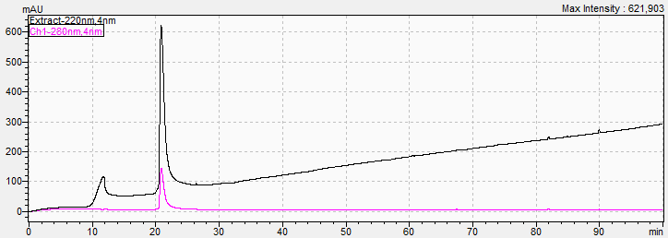

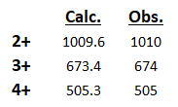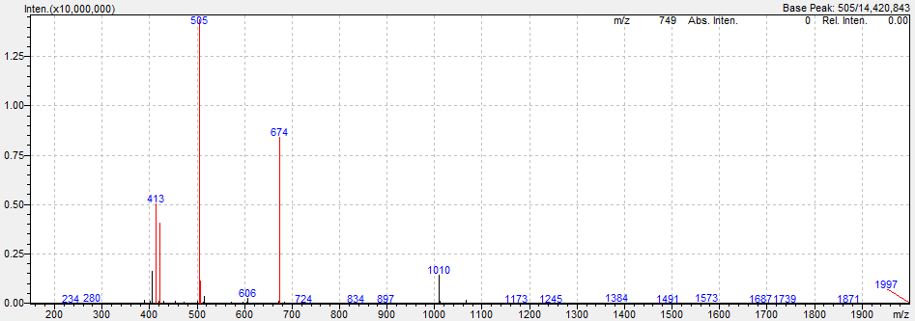

**Fig. S1.** *Top:* Analytical HPLC chromatogram (Luna Omega C18 column, linear gradient of 0-100 % solvent B over 100 minutes) and *Bottom:* ESI (+) mass spectrum of purified MAD1.

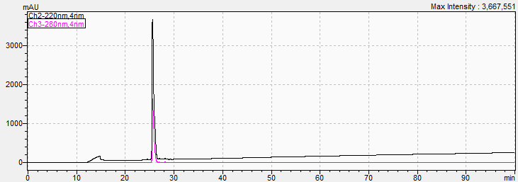

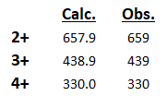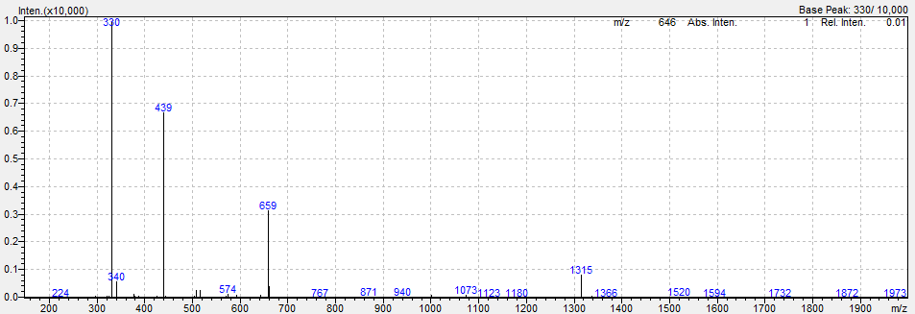

**Fig. S2.** *Top:* Analytical HPLC chromatogram (Luna Omega C18 column, linear gradient of 0-100 % solvent B over 100 minutes) and *Bottom:* ESI (+) mass spectrum of purified AMP1.

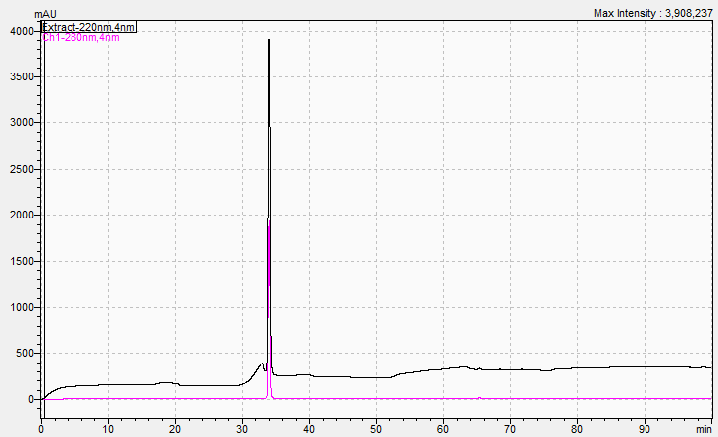

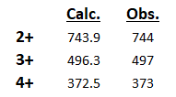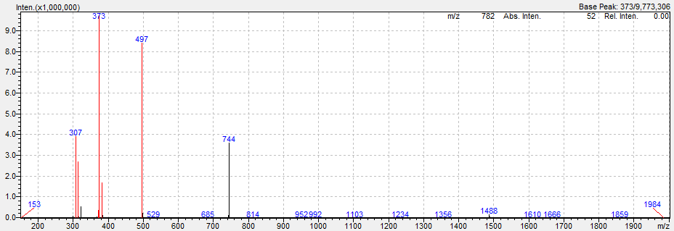

**Fig. S3.** *Top:* Analytical HPLC chromatogram (Luna Omega C18 column, linear gradient of 0-100 % solvent B over 100 minutes) and *Bottom:* ESI (+) mass spectrum of purified AMP2.

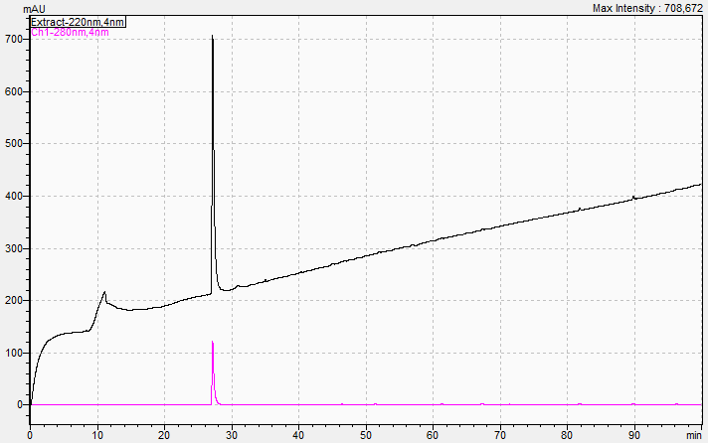

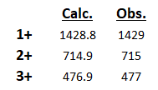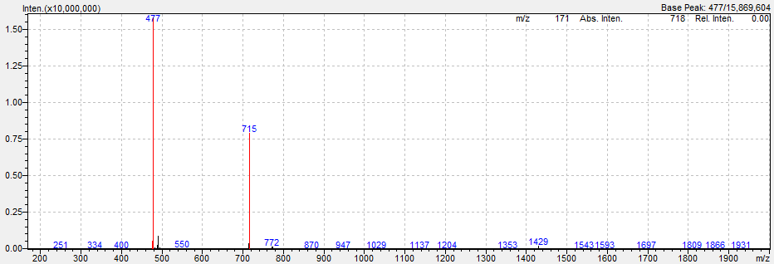

**Fig. S4.** *Top:* Analytical HPLC chromatogram (Luna Omega C18 column, linear gradient of 0-100 % solvent B over 100 minutes) and *Bottom:* ESI (+) mass spectrum of purified AMP3.

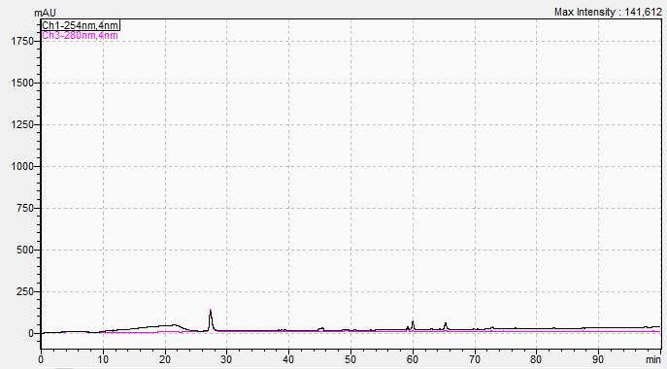

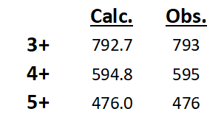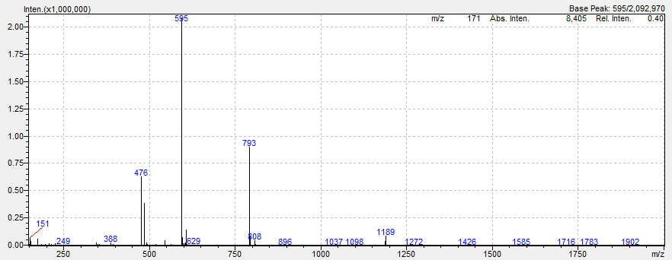

**Fig. S5.** *Top:* Analytical HPLC chromatogram (Luna Omega C18 column, linear gradient of 0-100 % solvent B over 100 minutes) and *Bottom:* ESI (+) mass spectrum of purified MAD1-FI.

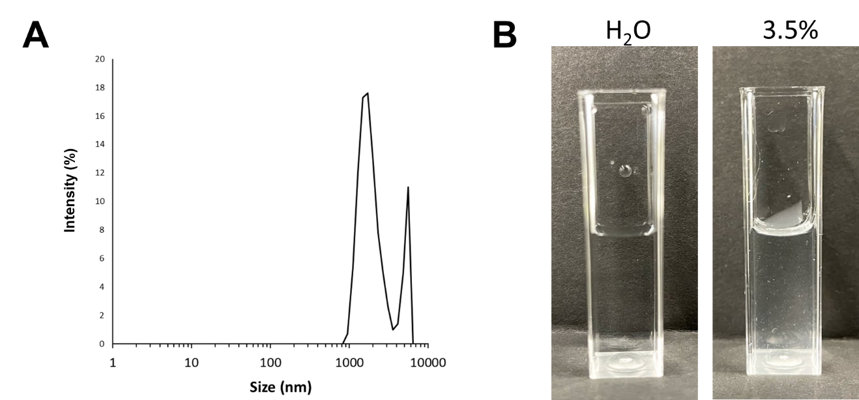

**Fig. S6.** (**A**) Dynamic light scattering analysis and (**B**)optical micrographs of AGMAD1 particle demonstrating particle flocculation when prepared using 3.5 wt% HA electrospray solutions.

**Table S1.** FIC values of peptide-drug combinations.

|  |  |  |  |  |  |
| --- | --- | --- | --- | --- | --- |
|  | | **Antibiotic\*** | | | |
| RIF | ETH | INH | MOX |
| **Peptide** | MAD1 | 0.53 | 0.63 | 0.75 | 0.28 |
| HDP1 | 2.00 | 1.00 | 0.63 | 1.00 |
| HDP2 | 0.75 | 2.00 | 0.75 | 1.00 |
| HDP3 | 2.50 | 1.50 | 3.00 | 1.50 |
| *Dark green indicates synergy, light green additive effects, and yellow independent interactions. | | | | | |



**Fig. S7.** Zeta potential comparison between un-loaded aerogels (AGMAD1) and MOX-loaded formulations (AGMAD1+MOX).

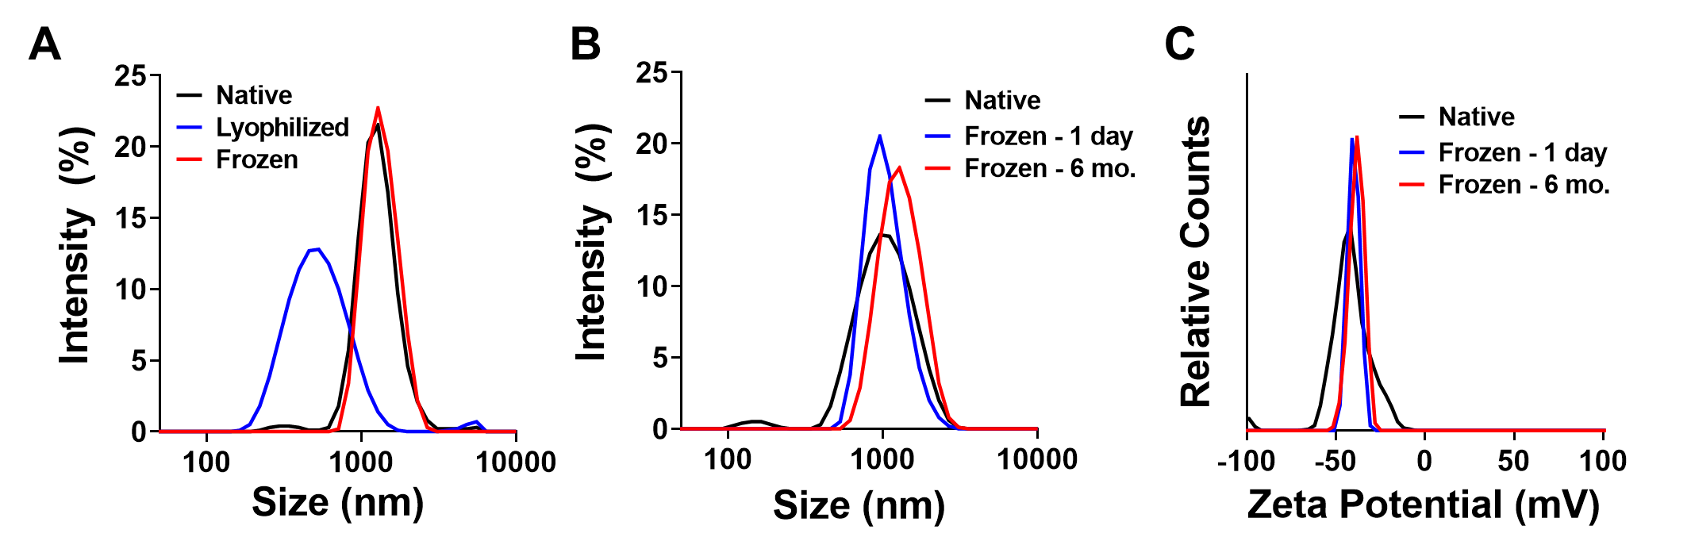

**Fig. S8.** (**A**) Particle size of un-loaded AGMAD1 particles immediately after synthesis (black) or samples subjected to lyophilization (blue) or freezing at -80°C (red). (**B**) Particle size and (**C**) zeta potential of AGMAD1+MOX particles before (black) and after frozen storage at -80°C for 1 day (blue) and 6 months (red).

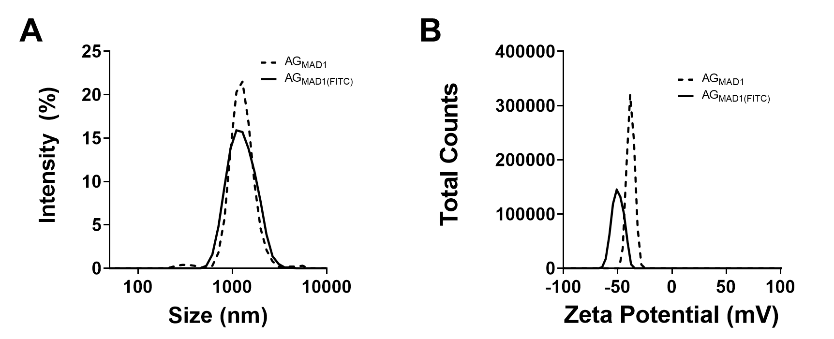

**Fig. S9.** (**A**) DLS and (**B**) zeta potential comparison between native AGMAD1 and fluorescently labelled particles (AGMAD1(FITC)).



**Fig. S10.** Average cellular fluorescence of THP-1 macrophages treated with fluorescent AGMAD1 particles at varying incubation times.

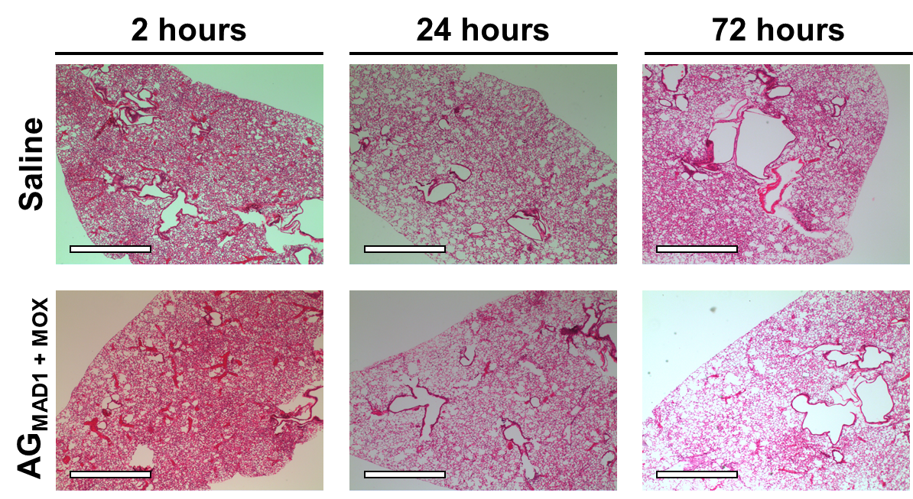

**Fig. S11.** Bright field micrographs (4x magnification) of H&E stained lung sections from C57BL/6J mice 2, 24 and 72 hours after inhalation exposure to saline (control) or a 20 mg/mL dose of AGMAD1+MOX particles. Scale bars = 1 mm.